Transaction flow

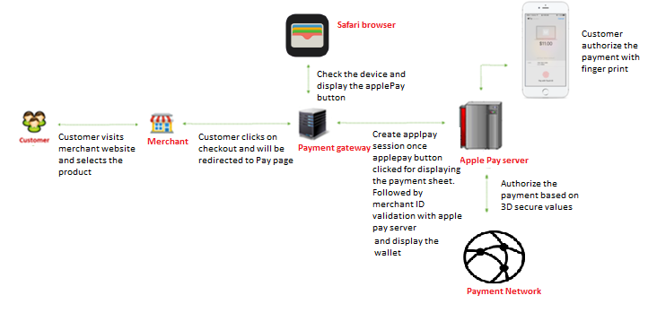

- Customer visits the merchant portal and selects the product and clicks on submit
- Customer redirected to Payment gateway. PG displays the payment page.
- In page, safari browser detects the device capabilities to determine if the apple Pay button should be displayed. Check that window. ApplePaySession class exists in the browser (this class manages the Apple Pay payment process in user website). Call its canMakePayments method to perform a basic hardware check to see if the shopper's device is capable of purchasing with Apple Pay.
- If the customer device is capable then displays the Apple Pay button in the payment page
- Customer clicks on apple pay the PG will create the Apple Pay session for validate the merchant with Apple Pay server.
- After validation, Payment sheet opens on top of payment page.
- Customer review the billing and shipping information and selects card to process the payments
- There is a notification to customer mobile device and customer has authorize the payment with their fingerprint.
- Once the authentication successful, internally Apple Pay server authorizes the payment based on 3D parameters and provides the success response to PG
- PG will update the response to merchant.

Following are the prerequisites for setting up Apple Pay
Create a developer account and follow the below steps.
- Register a Merchant ID
- Generate Payment Processing Certificate
- Register and verify website domain
- Generate Merchant Identity Certificate

Implementation Overview
The shopper experience with Apple Pay on the web
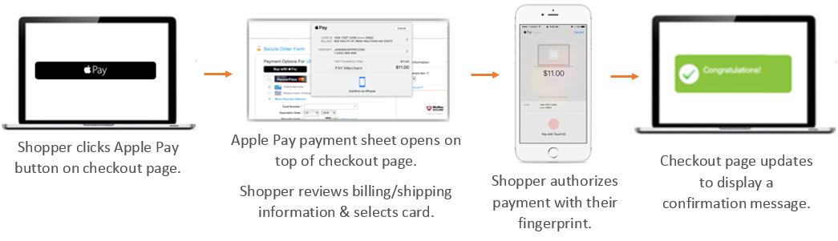

Requirements
Step1: Verify your domain
Step 2: Add and display the Apple Pay button
Step 3: Create an ApplePaySession
Step 4: Setup the validate merchant
Step 5: Payment authorization
Step 6: Show the payment sheet

Requirements

Shopper device requirements
Purchasing on an iOS device
Purchasing on a Mac
Safari must be open on an Apple Pay-enabled iPhone.
Safari must be open on a:
- MacBook Pro with Touch ID, or
- Mac model 2012 or later paired to a compatible iPhone/Apple Watch

Apple Pay requirements
Comply with Apple Pay Identity Guidelines and Apple Pay on the Web Human Interface Guidelines to ensure representing Apple Pay on our website.

Payment gateway Server requirements
- All pages that include Apple Pay must be served over HTTPS.
- Payment gateway domain must have a valid SSL certificate.

Step 1: Verify your domain
Using developer account, need to register all payment gateway transaction domains that will be displaying the Apple Pay button

Step 2: Add and display the Apple Pay button
This section covers how to add the Apple Pay button in Payment gateway site, and how to detect if the shopper is using a compatible device to determine if the button should be displayed.

Apple Pay requirements
On all pages where the shopper is presented with the Apple Pay button, required to adhere to the Apple Pay Identity Guidelines and Apple Pay on the Web Human Interface Guidelines.

2.1: Add the Apple Pay button in Pay page
Begin by adding a hidden Apple Pay button in PG page. Safari now comes with built-in Apple Pay images, which can be accessed using -webkit-named-image. The following black Apple Pay button with white text can be created using this feature.

Adding the Apple Pay button:
HTML
<button id="apple-pay-button"></button>

CSS
#apple-pay-button {
-webkit-appearance: -apple-pay-button;
-apple-pay-button-type: plain;
visibility: hidden; /* button is hidden by default */
display: inline-block;
width: 200px;
min-height: 30px;
border: 1px solid black;
background-image: -webkit-named-image(apple-pay-logo-white);
background-size: 100% calc(60% + 2px);
background-repeat: no-repeat;
background-color: black;
background-position: 50% 50%;
border-radius: 5px;
padding: 0px;
margin: 5px auto;
}

2.2: Display the Apple Pay button on a compatible device
Detect the shopper's browser and device capabilities to determine if the Apple Pay button should be displayed. Check that window.ApplePaySession class exists in the browser (this class manages the Apple Pay payment process in your website). Call its canMakePayments method to perform a basic hardware check to see if the shopper's device is capable of purchasing with Apple Pay.

JavaScript
if (window.ApplePaySession && ApplePaySession.canMakePayments()) {
// Device supports Apple Pay
// Show Apple Pay button...
}
If you want to default to Apple Pay during your checkout flow, or if you want to add Apple Pay buttons to your product detail page, use the canMakePaymentsWithActiveCard method. This asynchronous call requires Merchant ID, and detects both that the shopper's device supports Apple Pay and that there is at least one card provisioned in their account. If checking Apple Pay compatibility at any other point, use canMakePayments instead.
Merchant ID when calling ApplePaySession.canMakePaymentsWithActiveCard.

JavaScript
if (window.ApplePaySession) {
var merchantID = "123456" // Merchant ID;
var promise = ApplePaySession.canMakePaymentsWithActiveCard(merchantID);
promise.then(function (canMakePaymentsWithActiveCard) {
if (canMakePaymentsWithActiveCard) {
// Device supports Apple Pay & user has at least 1 provisioned card
// Show Apple Pay button...
}
}
}

Step 3: Create an ApplePaySession
A new ApplePaySession instance should be created every time the Apple Pay button is clicked/tapped.
adding an event listener on the button that calls applePayClicked when the button is clicked. This callback function is where the majority of Apple Pay implementation takes place.

JavaScript
document.getElementById('apple-pay-button').addEventListener('click', applePayClicked);
To begin, do the following within applePayClicked:
- Create a payment request object (an object that contains all the information needed to display the payment sheet).
- Create a new ApplePaySession instance.

For the payment request object, requires the following information to complete a transaction, in addition to Apple Pay's requirements

Payment API
Extended Payment API
- requiredBillingContactFields
  - postalAddress
  - name
- requiredBillingContactFields
  - postalAddress
  - name
- requiredShippingContactFields
  - postalAddress
  - name
  - phoneticName
  - phone
  - email

Note
No need to enter the actual information; need to specify the parameters that you want to pull from the shopper. For example, if you want to request the shopper's billing address, you specify: requiredBillingContactFields: [ 'postalAddress']

The following is an example of a new ApplePaySession creation:

JavaScript
function applePayClicked() {
var request = {
countryCode: 'US',
currencyCode: 'USD',
total: { label: 'Your Label', amount: '10.00', type: 'final' },
supportedNetworks:[ 'masterCard', 'visa' ],
merchantCapabilities: [ 'supports3DS' ],
requiredBillingContactFields: [ 'postalAddress', 'name' ],
requiredShippingContactFields: [ 'postalAddress', 'email', 'phone' ]
};
var session = new ApplePaySession(2, request);
// continued below
}
When creating a new ApplePaySession instance, a JavaScript exception is thrown if any of the following occur:
- Any Apple Pay JavaScript API is called from an unsecured page.
- You pass an invalid payment request. Payment requests are invalid if they contain missing, unknown, or invalid properties, or if they have a negative total.

Step 4: Validate the merchant
The callback function onvalidatemerchant is automatically called with an event object when the payment sheet is displayed. Merchant validation is initiated so Apple can verify the eligibility to accept Apple Pay on the website.

JavaScript
function applePayClicked() {
// continued from above
session.onvalidatemerchant = function(event) {
var validationURL = event.validationURL;
// send validationURL to your server...

// ...return base64 decoded token
var decodedToken = {base64 decoded token};
session.completeMerchantValidation(JSON.parse(decodedToken)); //to abort the session, use session.abort()
};
// continued below
}

When called, completeMerchantValidation completes the merchant validation process. The payment sheet updates to request the shopper's authorization.

Create Wallet API call
The Create Wallet request is done as part of the merchant validation process. Perform this call after you've sent the URL from event.validationURL to your server.
The Create Wallet request should be sent to /services/2/wallets, and should contain the following properties:
- Wallet Type — value is APPLE_PAY.
- Validation URL — value extracted from event.validationURL.
- Domain Name — The name of your domain that you verified in Step 1.
- Display Name — (optional) The name of your store. On certain models of MacBook Pro, the system displays this name to the user in the Touch Bar. The value is up to 65 UTF-8 characters. If this is not included, the system displays registered Merchant Name.
- Sample Create Wallet requests:
JSON

{
"walletType": "APPLE_PAY",
"validationUrl": "https://apple-pay-gateway-cert.apple.com/paymentservices/startSession",
"domainName": "merchant.com",
"displayName": "My Store"
}
A successful response contains the Wallet Token (a base64 encoded string).
Sample Create Wallet response:
JSON

XML
{
"walletType": "APPLE_PAY",
"walletToken":"ImRhdGEiOiJuY1AvRitIUy8zeG5ISk1pSm9RbXhCMFd"
}

Step 5: Authorization
The callback function onpaymentauthorized is automatically called with an event object when the shopper has authorized the payment (typically via Touch ID).

JavaScript
function applePayClicked() {
// continued from above
session.onpaymentauthorized = function(event) {
var paymentToken = event.payment;
// send paymentToken to server...

// ...return a status to completePayment & direct to appropriate page
session.completePayment(ApplePaySession.STATUS_SUCCESS); //or pass another valid status code - see below
window.location.href = "/success.html";
};
// continued below
}

Step 6: Show the payment sheet
After adding all event handlers, call your session's begin method to show the payment sheet to the shopper. Note that if the session isn’t explicitly requested by the customer (i.e. inside a click event), the begin method throws a JavaScript exception.

JavaScript
function applePayClicked() {
// continued from above
session.begin();
}
After the begin method is called, your session's onvalidatemerchant callback function is called. The other callback functions are called when their corresponding events are triggered as the shopper proceeds through checkout.

